ADITHYA R
192311369

20.Demonstrate Infrastructure as a Service (IaaS) by establishing the remote connection, launch the created VM image and run in your desktop using Azure.
Answer:
AIM: To demonstrate Infrastructure as a Service (IaaS) by establishing a remote connection to a created Virtual Machine (VM) in Microsoft Azure and running it from a local desktop system
Procedure:
STEP 1: Login to Azure Portal
- Open browser → Go to https://portal.azure.com
- Login with Azure credentials.

STEP 2: Navigate to Virtual Machine
- In the search bar, type Virtual Machines.
- Select the created VM (e.g., IaaS-Demo-VM).
- Ensure VM Status shows Running.
  - If stopped, click Start.

CASE 1: Remote Connection to Windows VM (Using RDP)
STEP 3A: Download RDP File
- Inside VM dashboard, click Connect.
- Select RDP.
- Click Download RDP File.
STEP 4A: Establish Connection
- Open the downloaded .rdp file.
- Click Connect.
- Enter Username and Password created during VM setup.
- Click OK.
✅ Windows Virtual Machine desktop opens on your local system.

CASE 2: Remote Connection to Linux VM (Using SSH)
STEP 3B: Get Public IP Address
- In VM Overview page, copy the Public IP Address.
STEP 4B: Connect Using SSH (PowerShell)
Open PowerShell / Command Prompt:
ssh azureuser@PublicIP
Example:
ssh azureuser@20.204.45.100
- Type Yes for fingerprint confirmation.
- Enter password.
✅ Linux VM terminal access established.

STEP 5: Verify VM is Running
For Windows VM:
- Open Notepad or File Explorer to verify system access.
For Linux VM:
ls
pwd
uname -a
These commands confirm the VM is active and running.

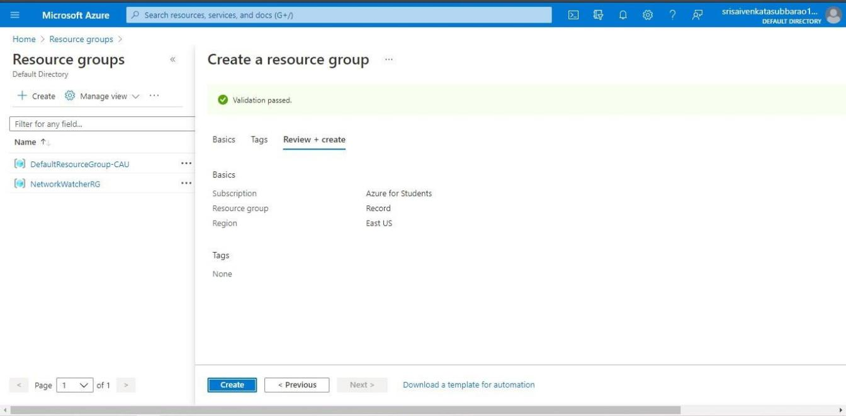

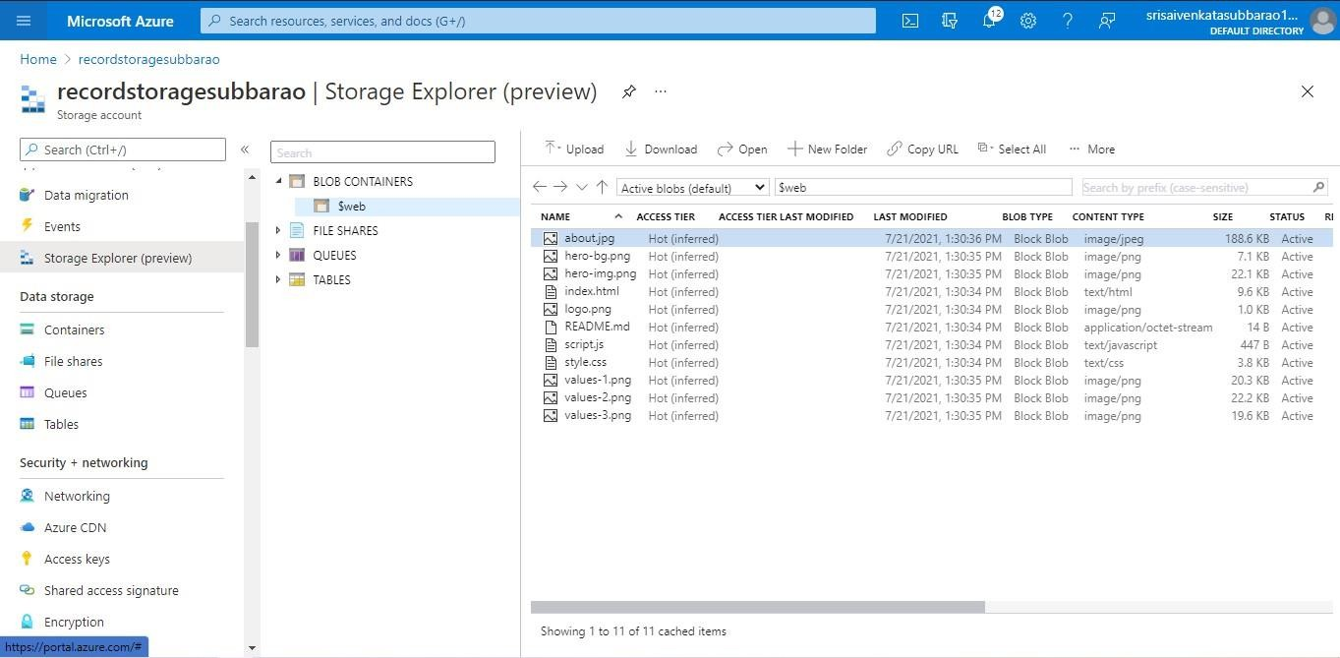

RESULT:
The remote connection to the Azure Virtual Machine was successfully established using RDP/SSH.
The created VM image was launched and accessed from the local desktop system.
Thus, Infrastructure as a Service (IaaS) was successfully demonstrated by provisioning and remotely managing a virtual machine using Microsoft Azure.

